|  |
| --- |
|  |
| TPI - Chronoview |
| Code Source |
|  |
| **Zoé Cugni** |
| **19/06/2017** |

|  |
| --- |
|  |

# Table des matières

1. Table des matières 1

2. Index.php 2

3. Login.php 6

4. Js/timeline.js 7

5. Js/lightbox.js 15

6. Functions/dao.php 25

7. Functions/dbCoConfig.php 30

8. Functions/interlocutor/event.php 31

9. Functions/interlocutor/getCategories.php 31

10. Functions/interlocutor/getSession.php 32

11. Functions/interlocutor/loginCheck.php 32

12. Functions/interlocutor/rangeYear.php 33

13. Functions/interlocutor/updateEvent.php 34

14. Functions/interlocutor/updateCategory.php 35

15. Functions/interlocutor/insertCategory.php 35

16. Functions/interlocutor/insertEvent.php 36

17. Functions/interlocutor/deleteCategory.php 37

18. Functions/interlocutor/deleteEvent.php 37

19. Css/style.scss 38

# Index.php

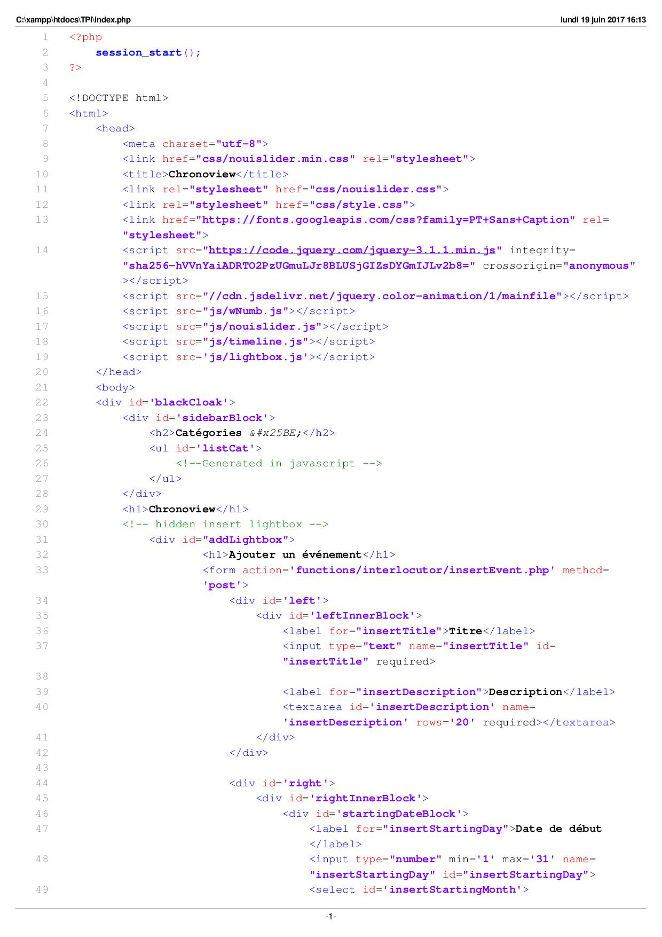

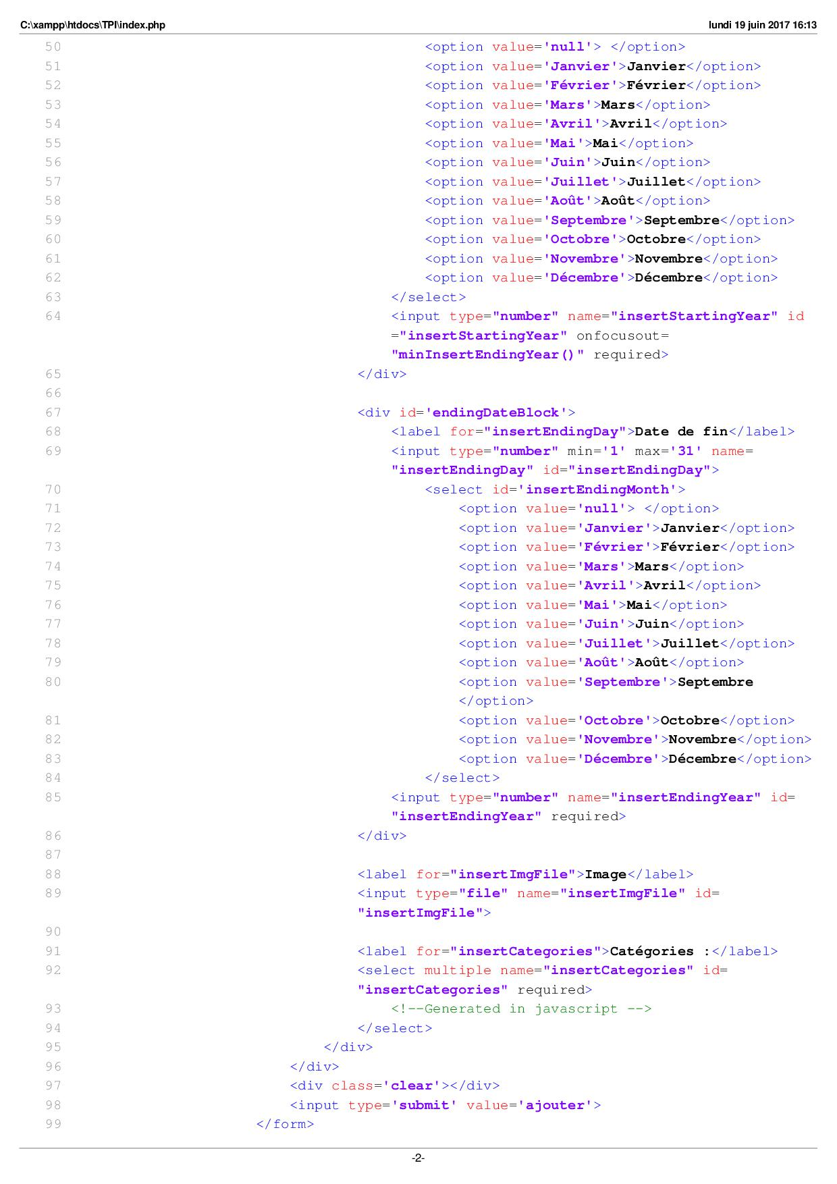

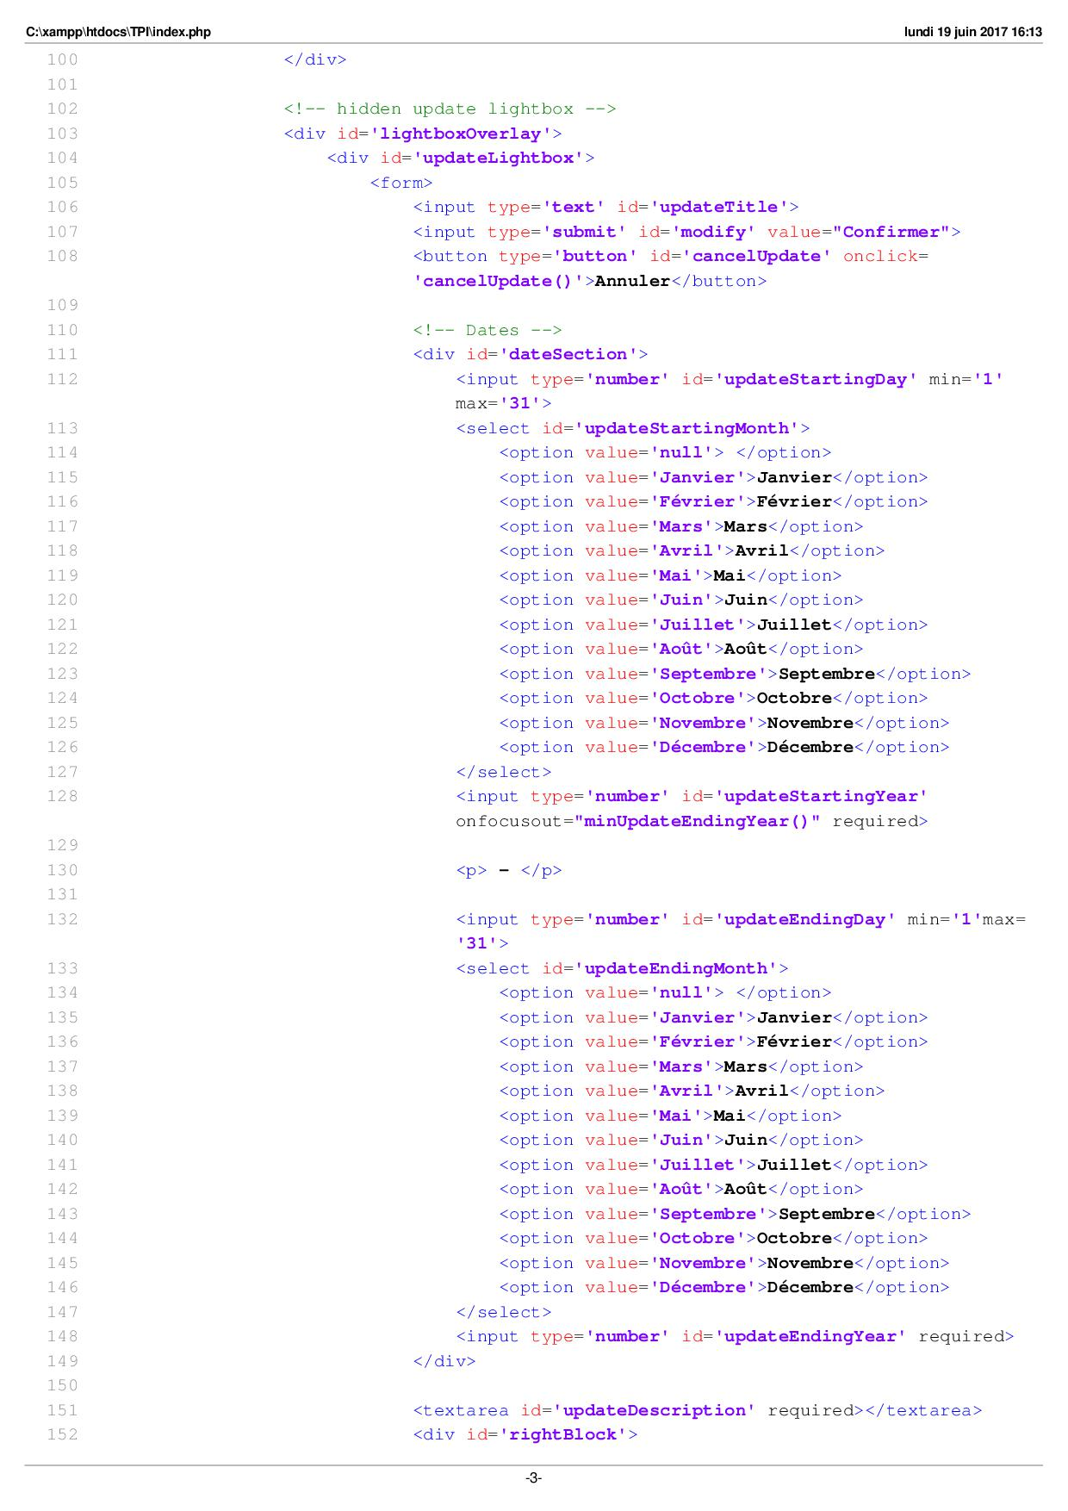

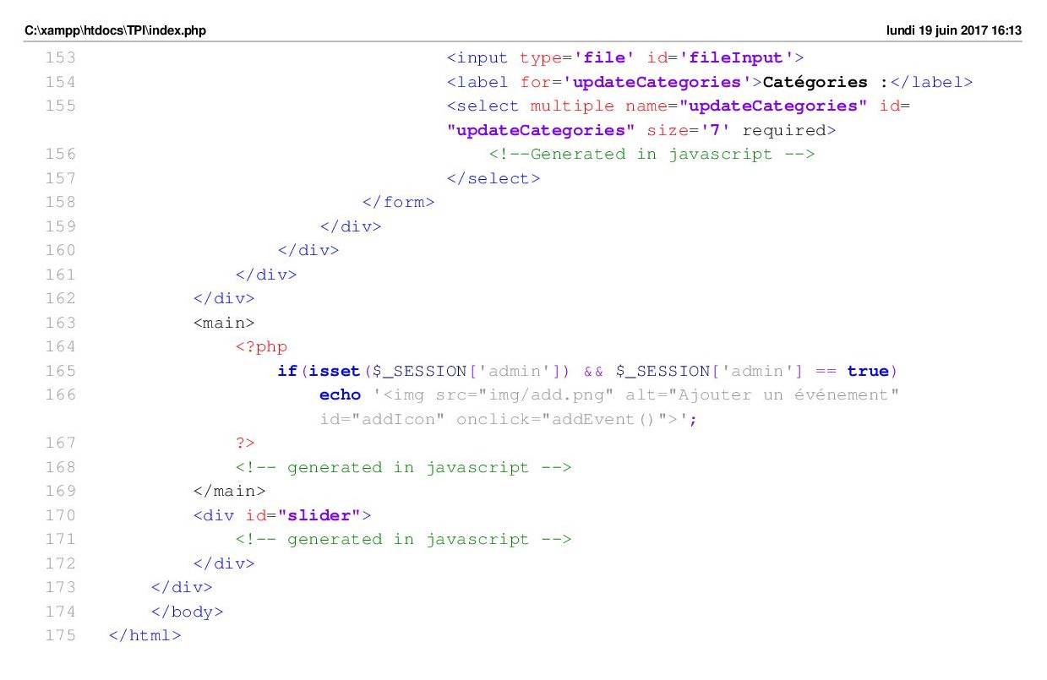

# Login.php

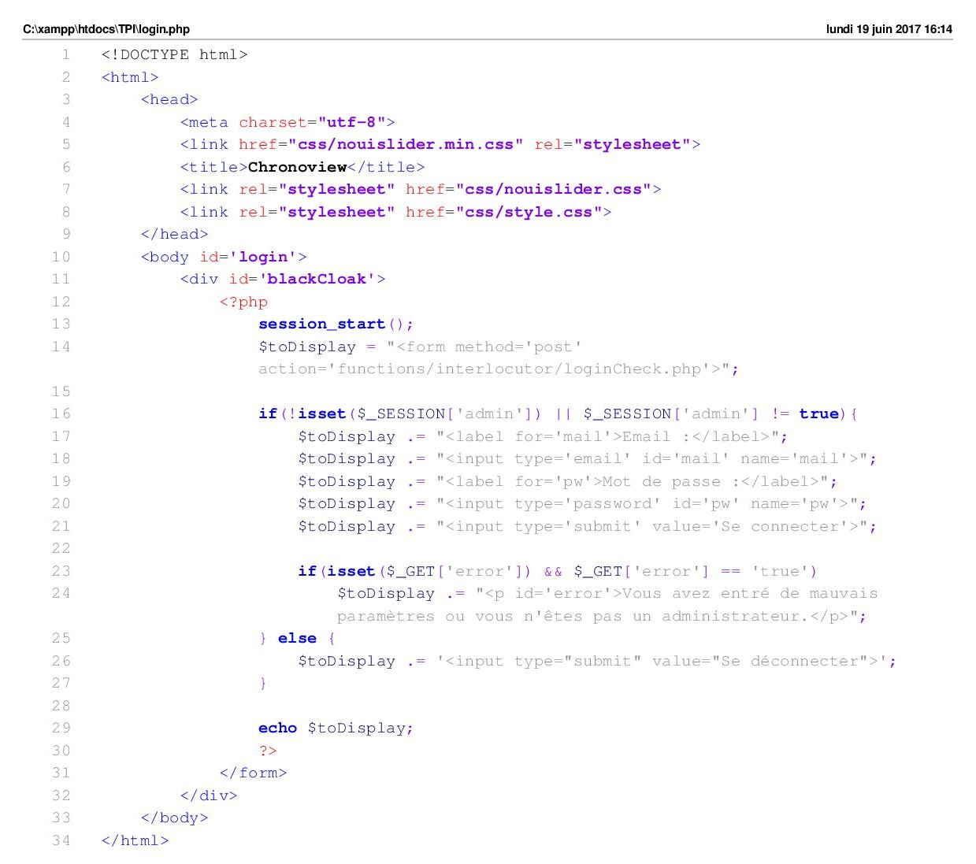

# Js/timeline.js

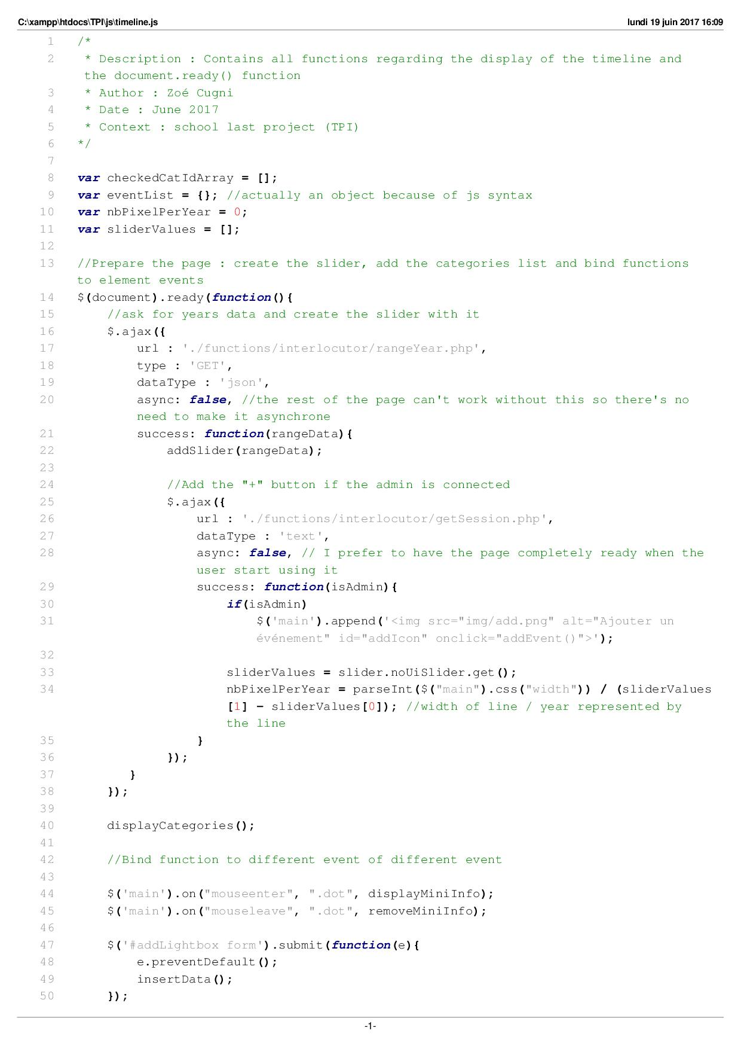

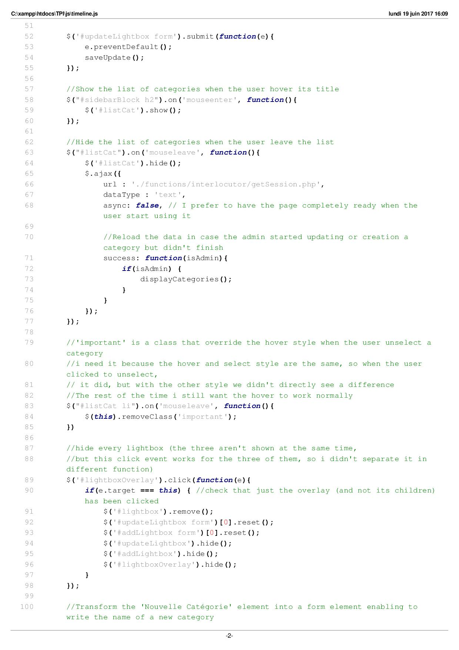

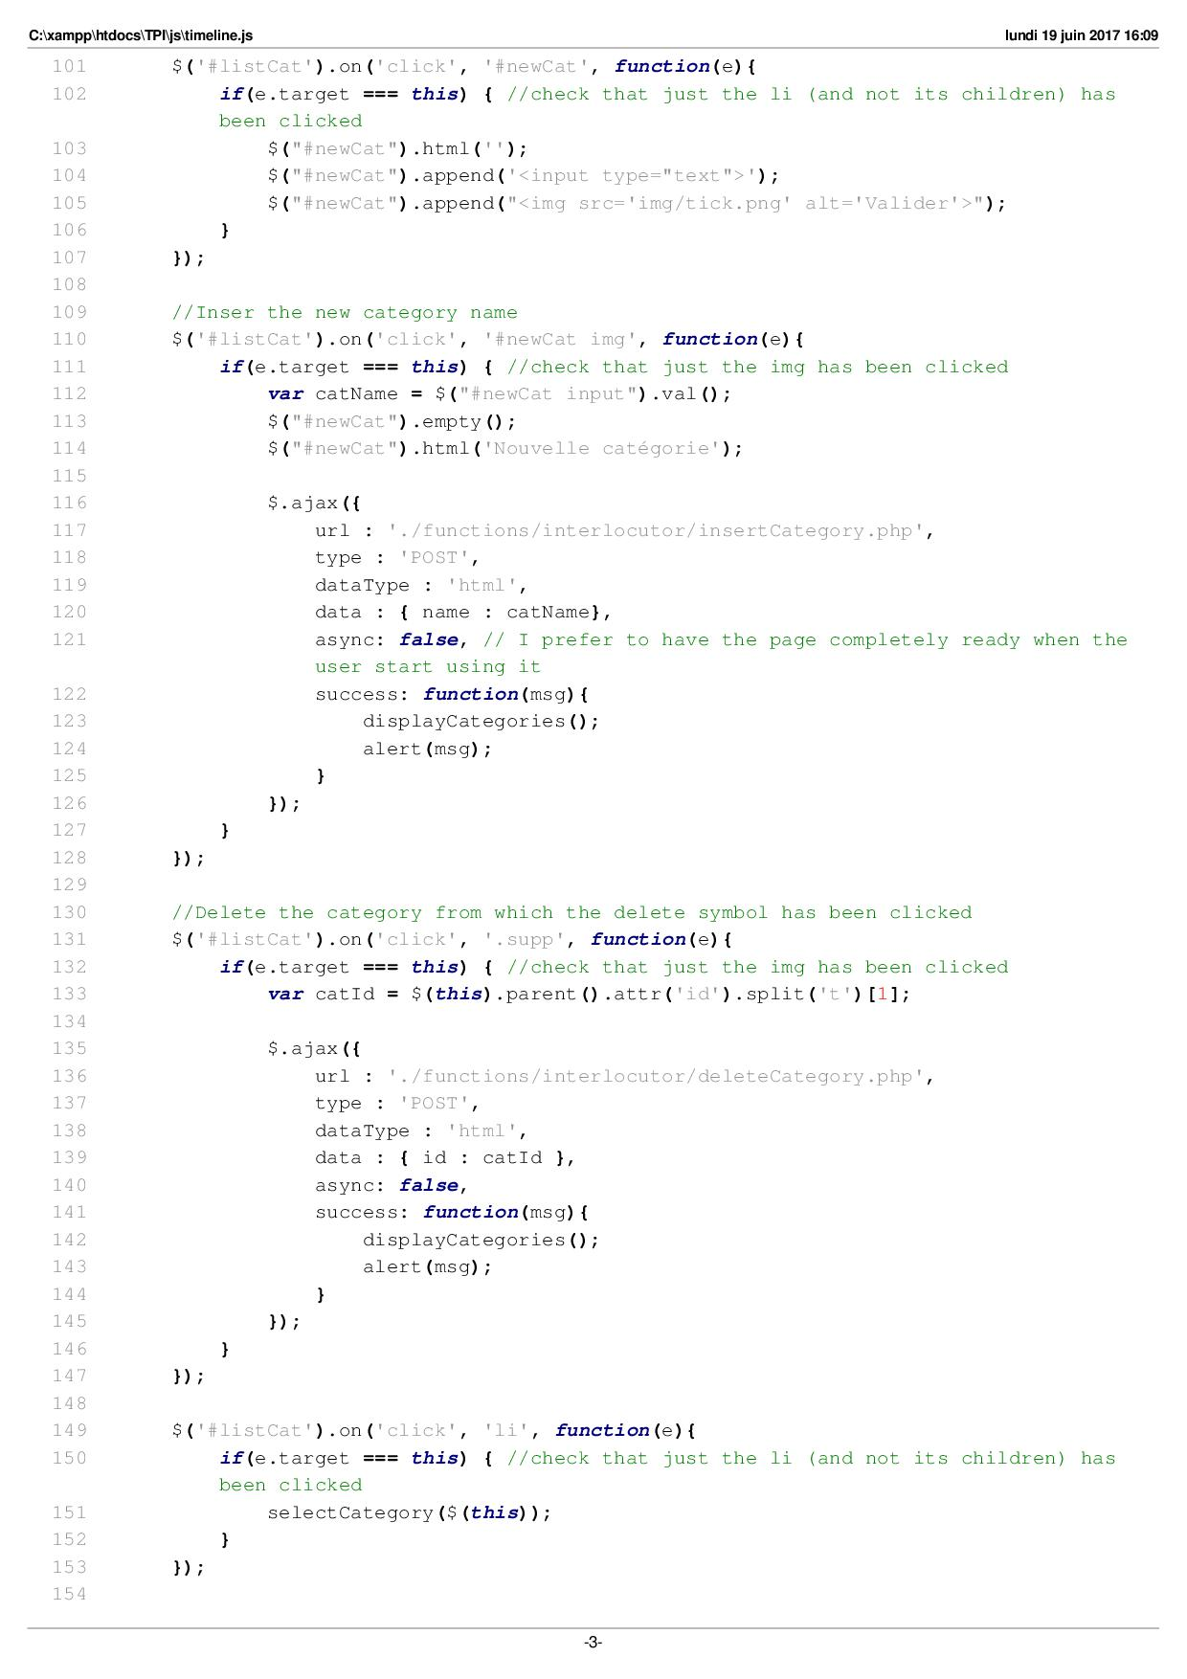

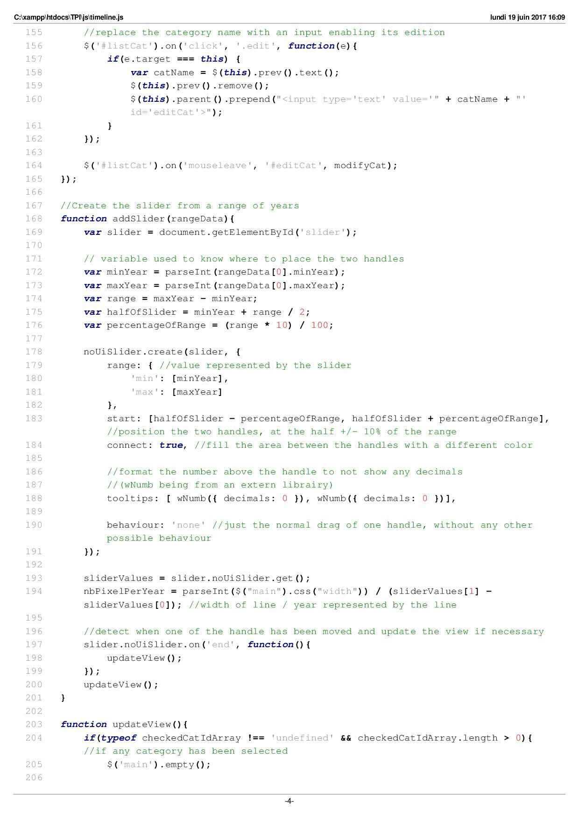

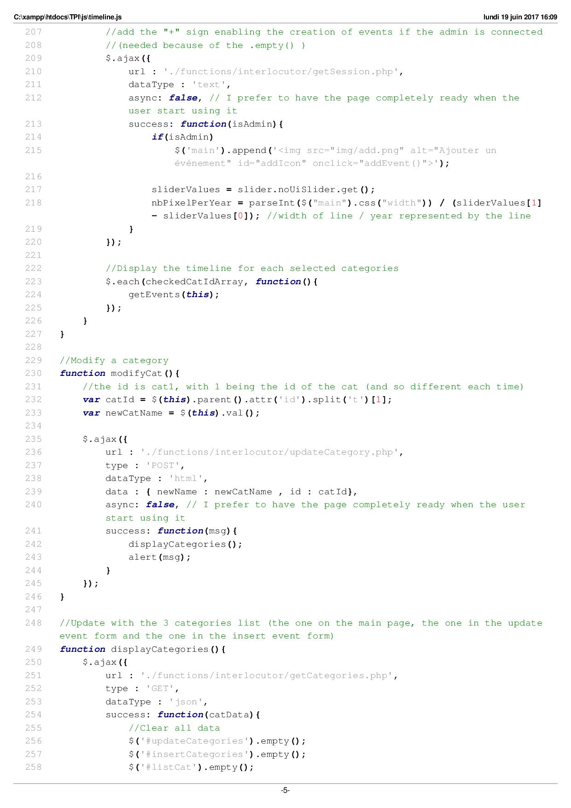

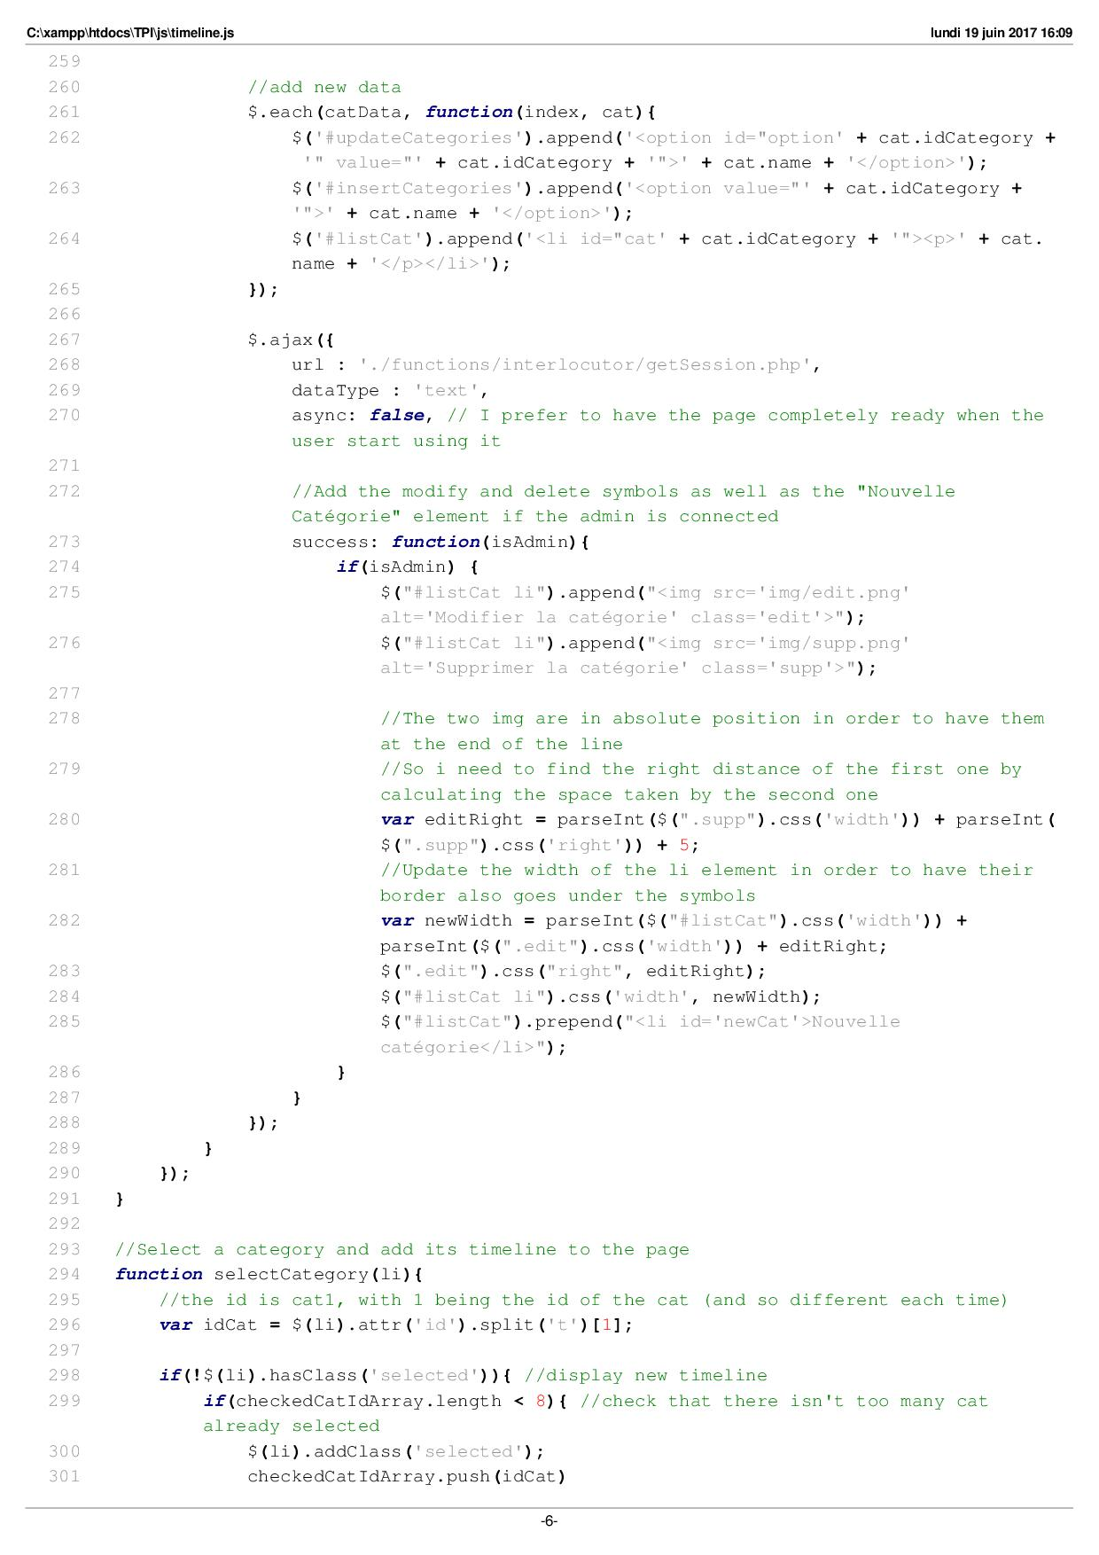

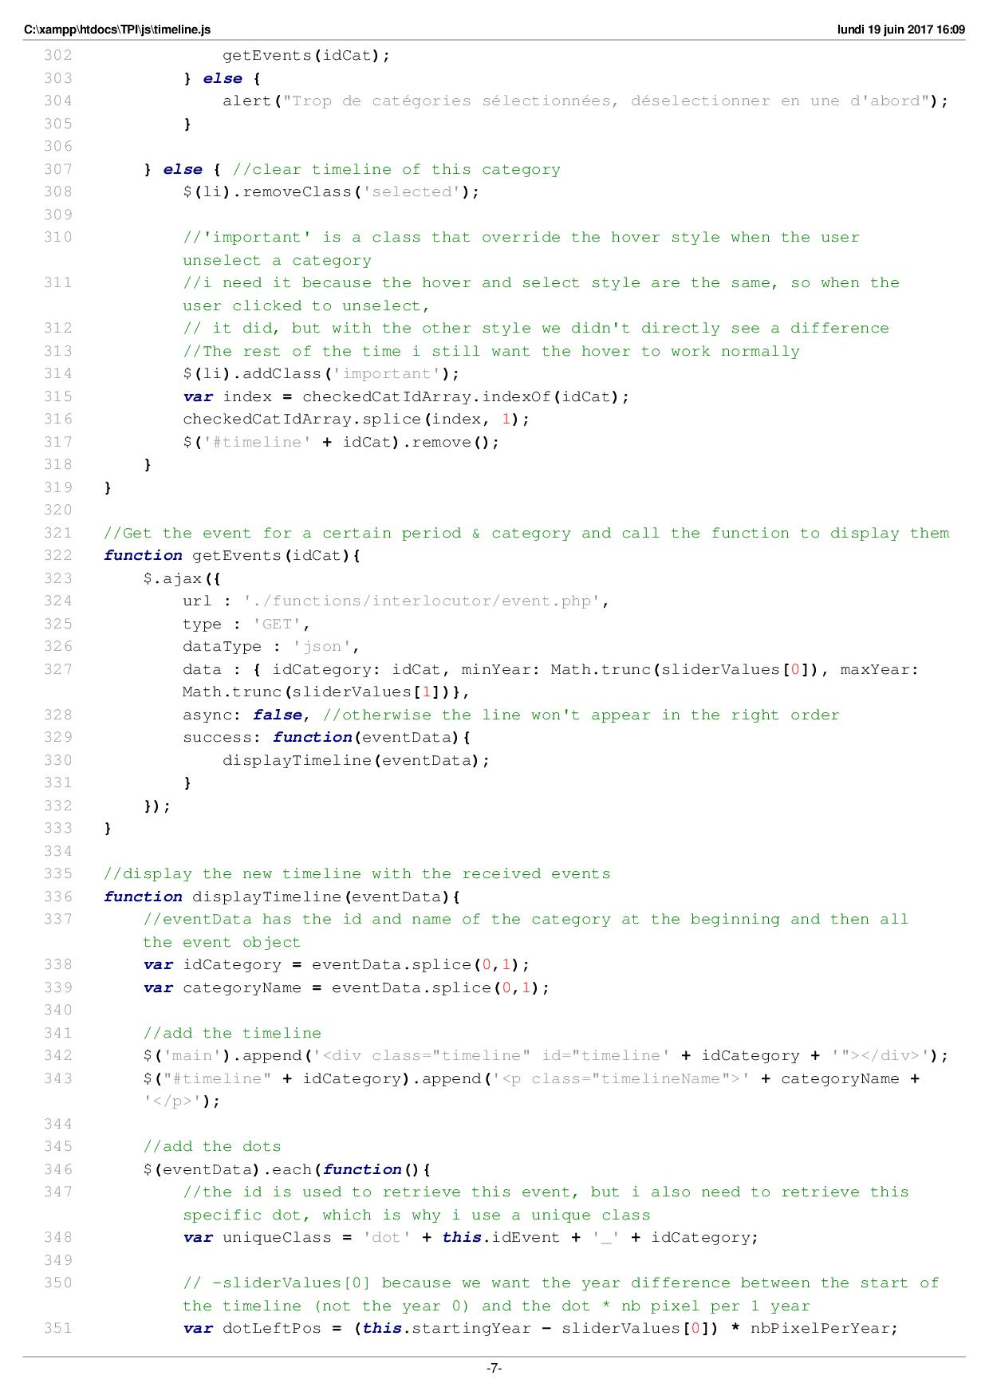

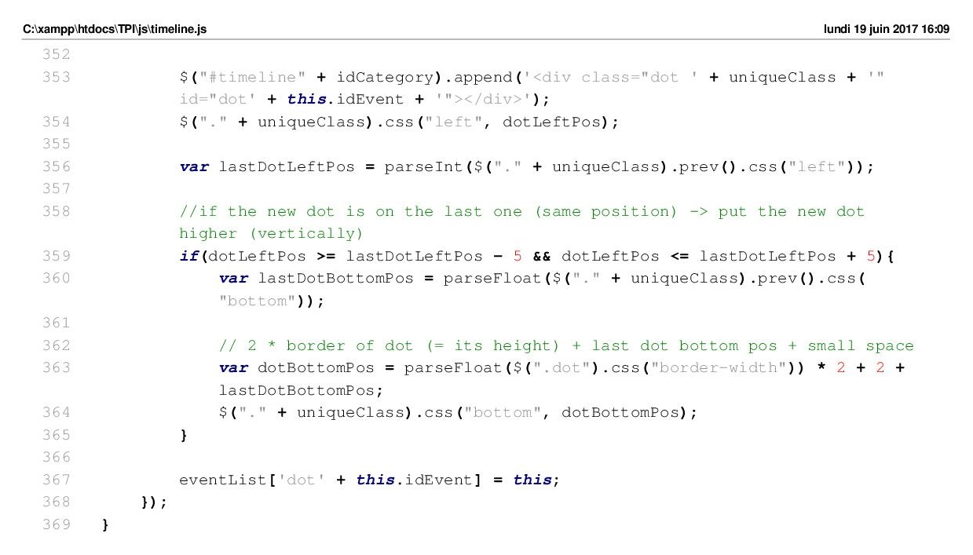

# Js/lightbox.js

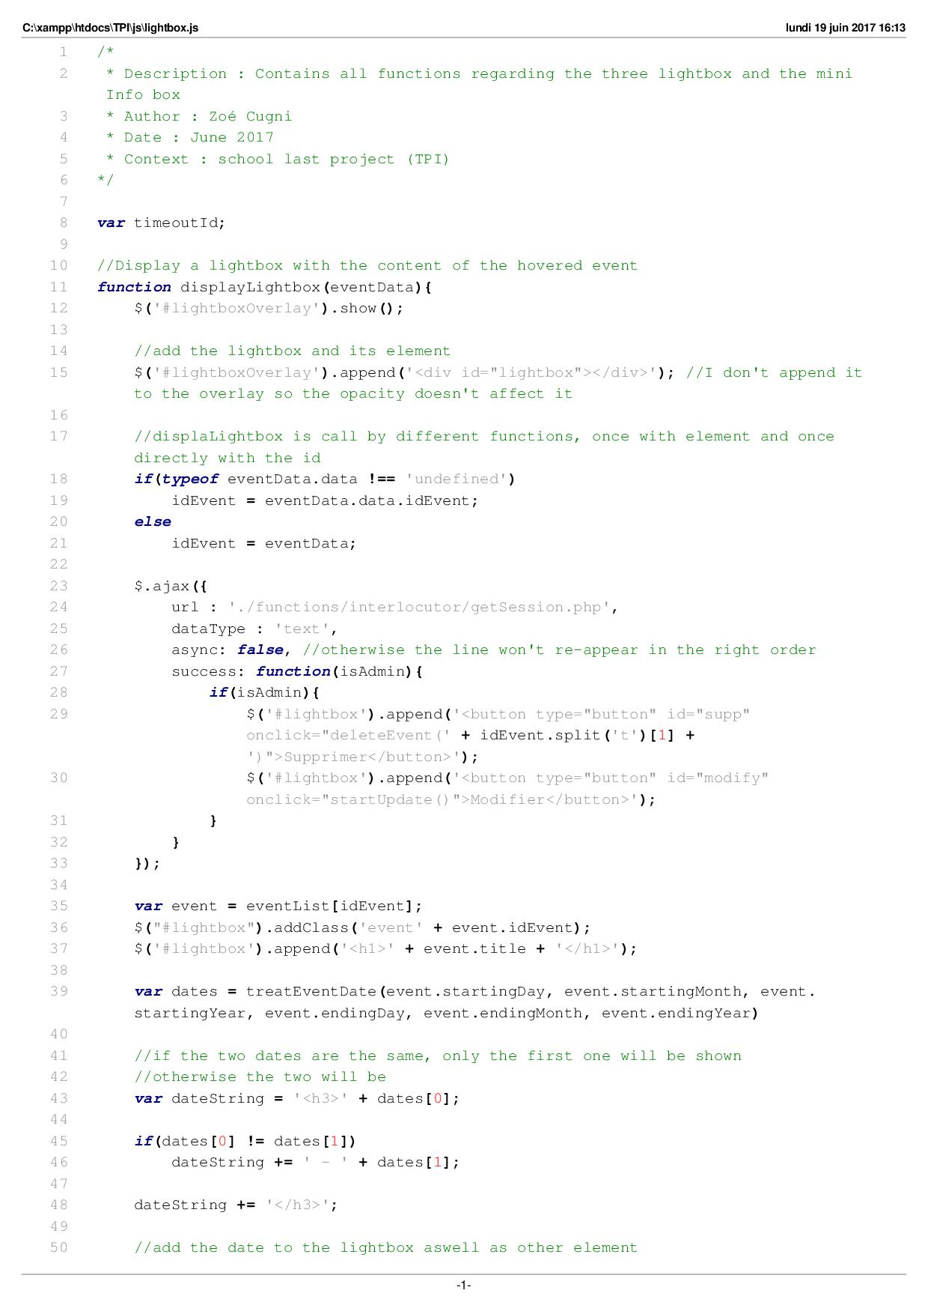

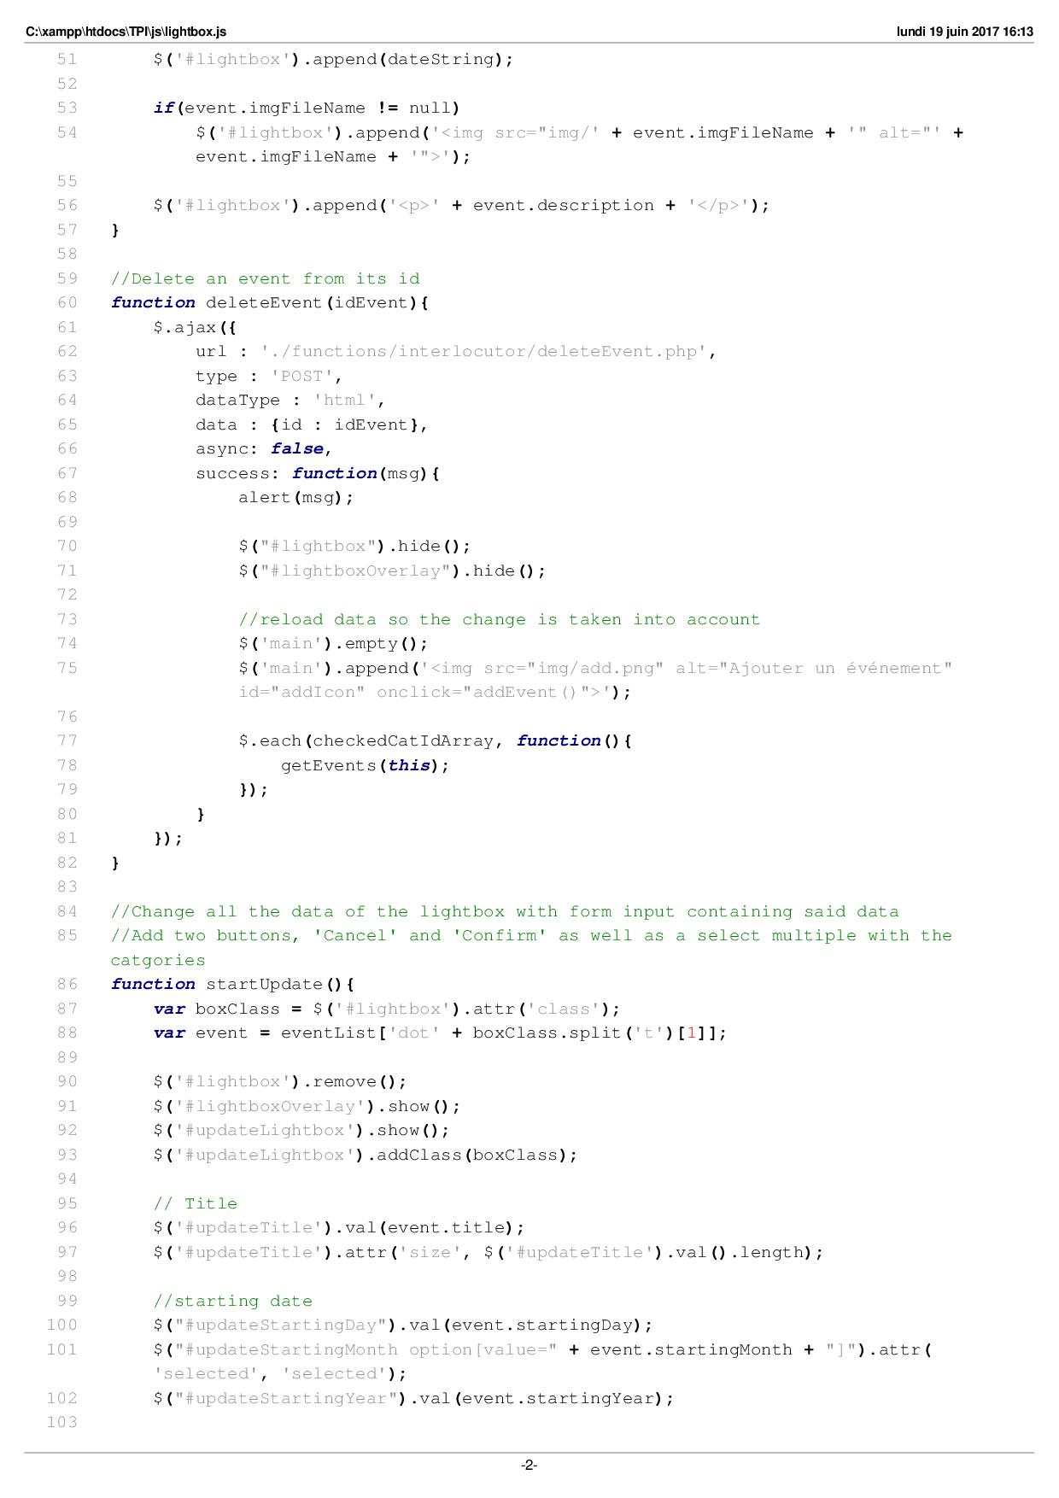

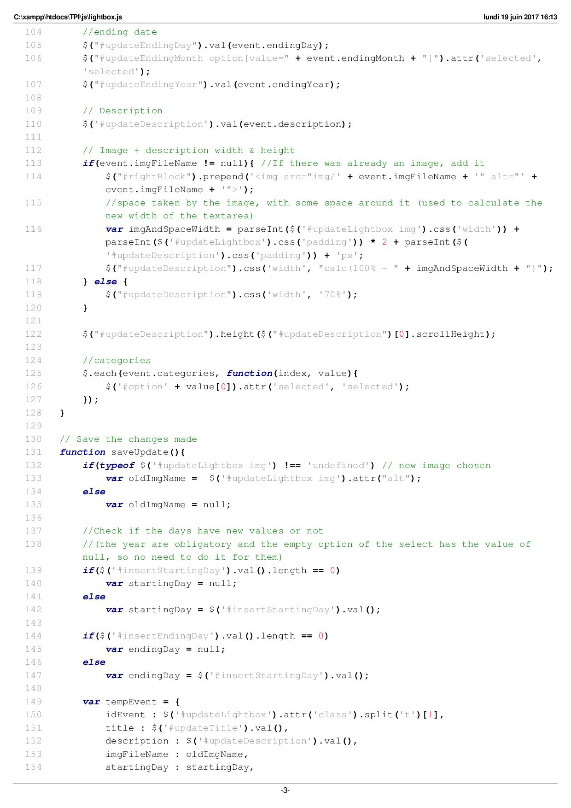

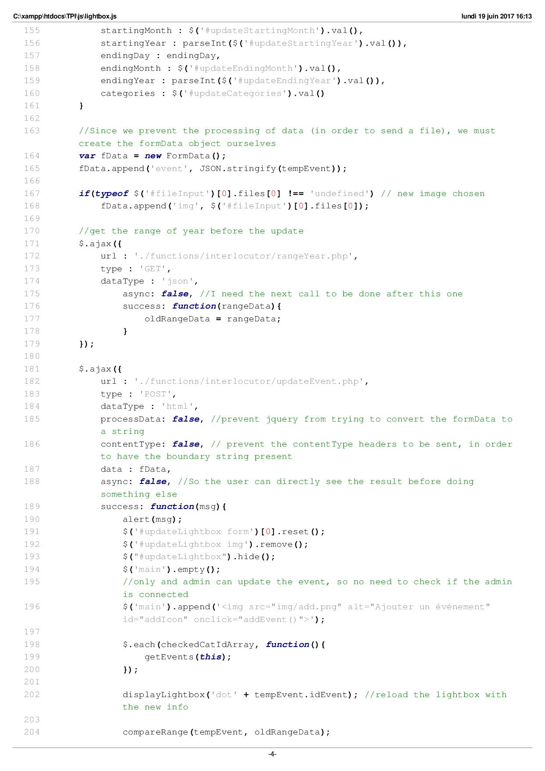

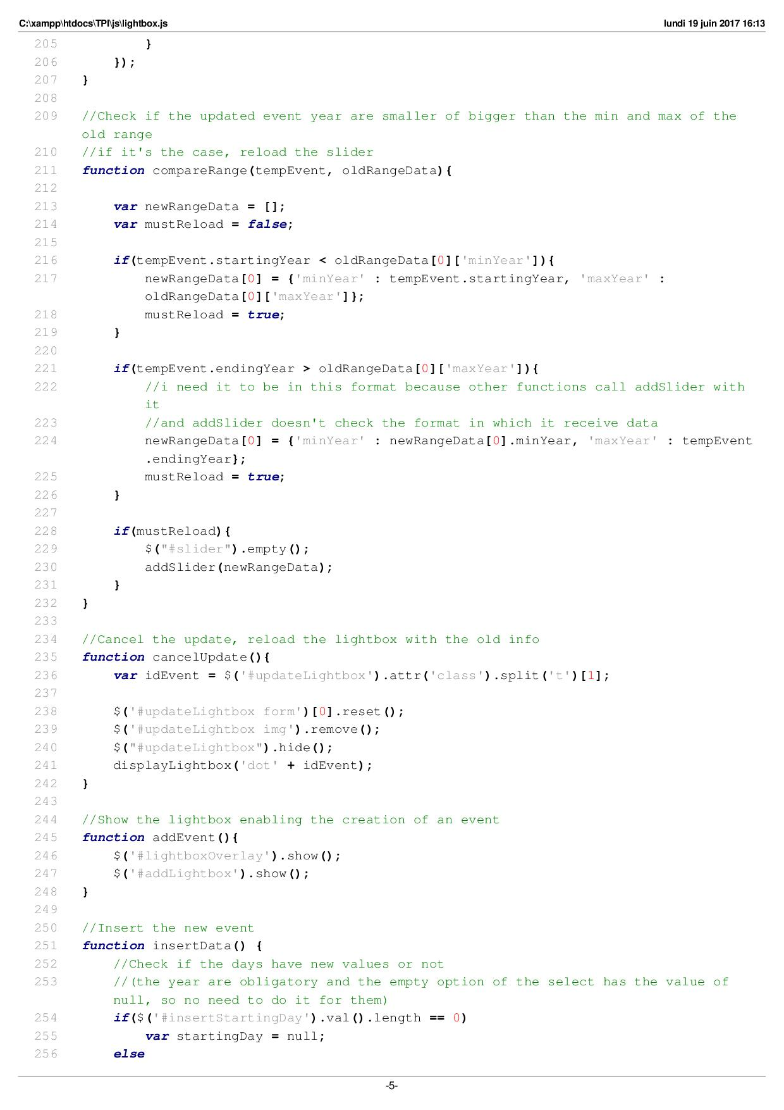

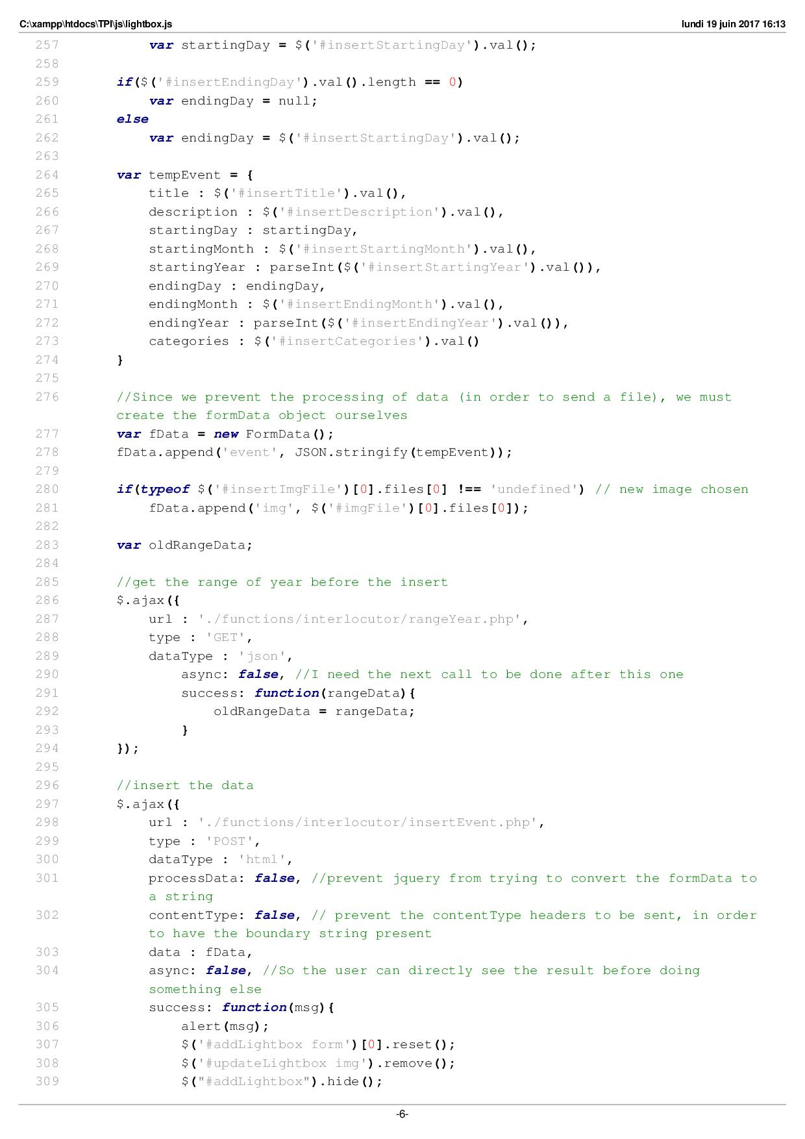

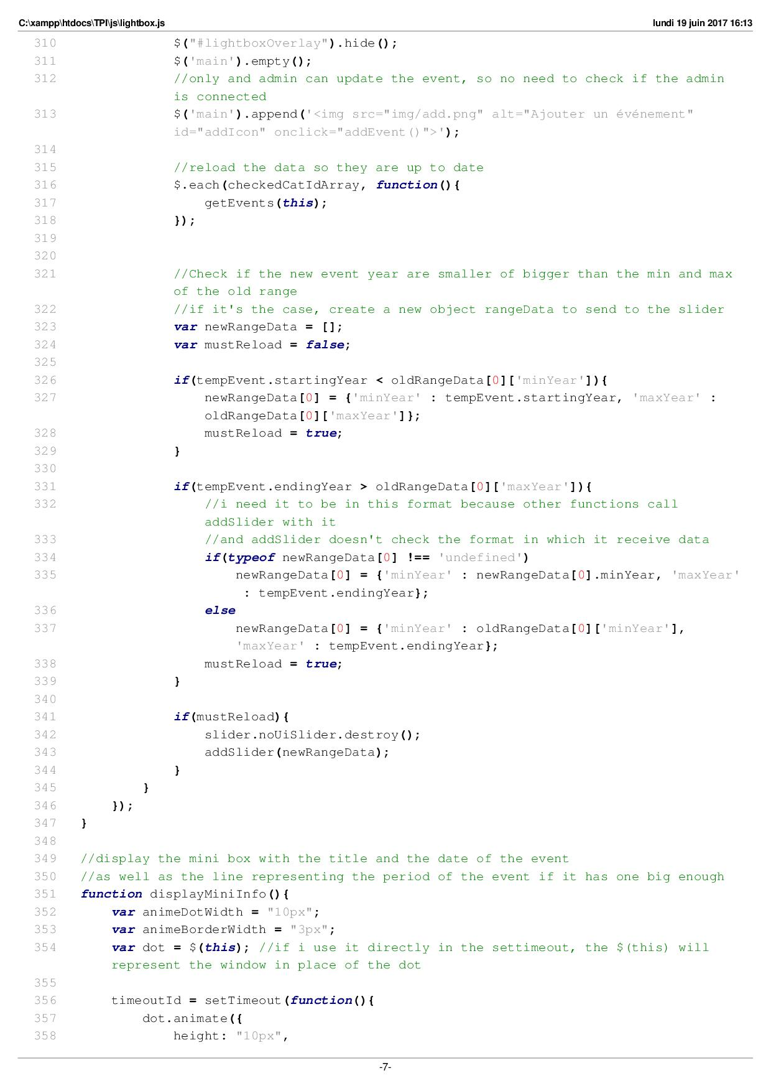

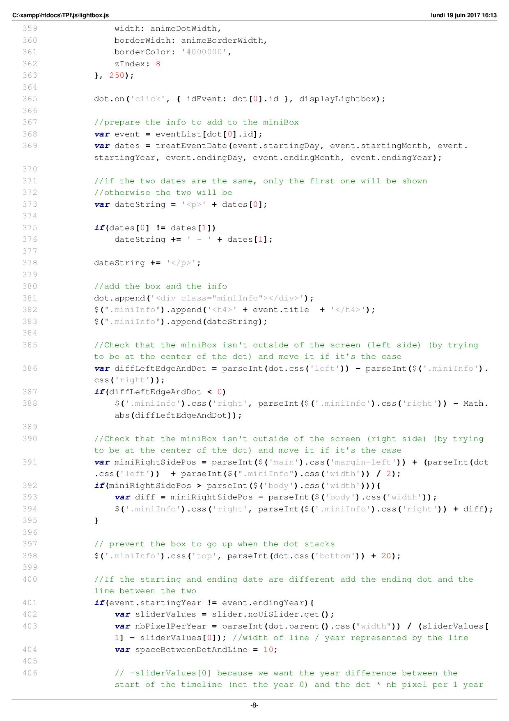

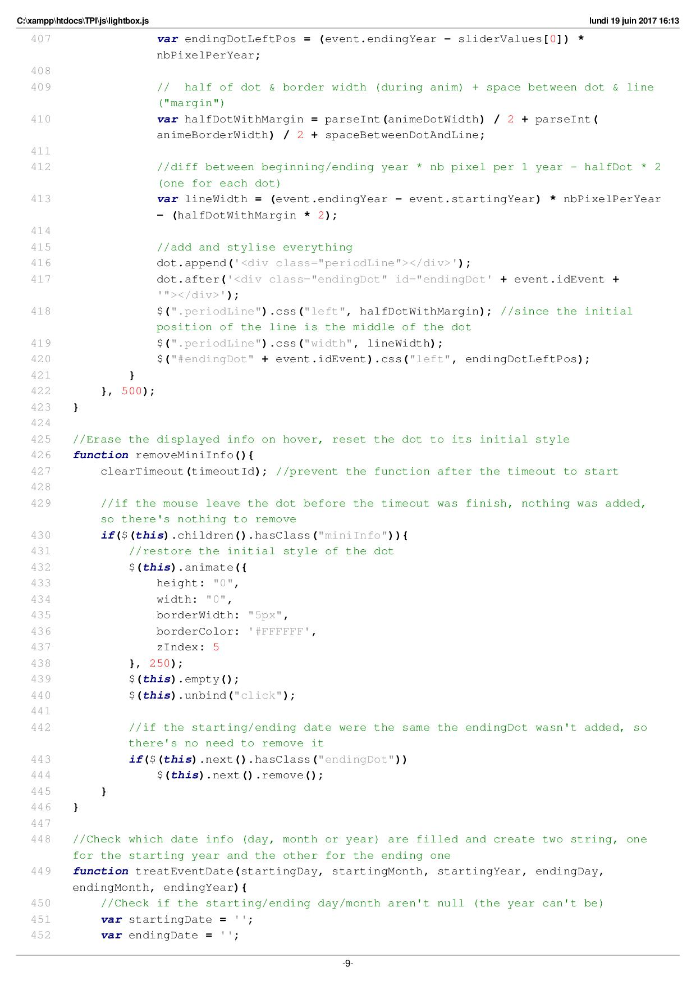

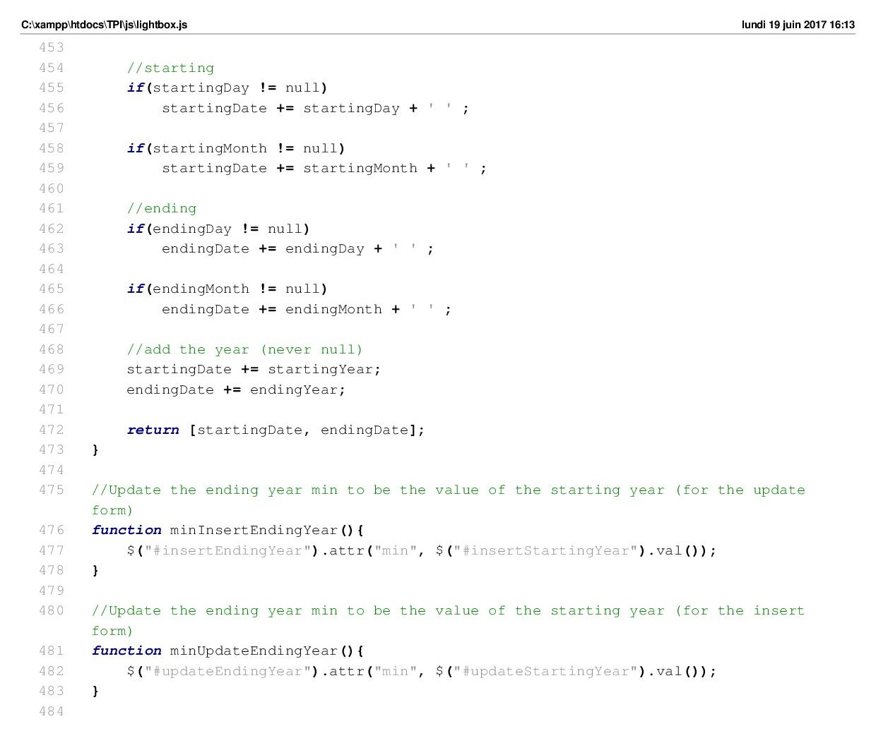

# Functions/dao.php

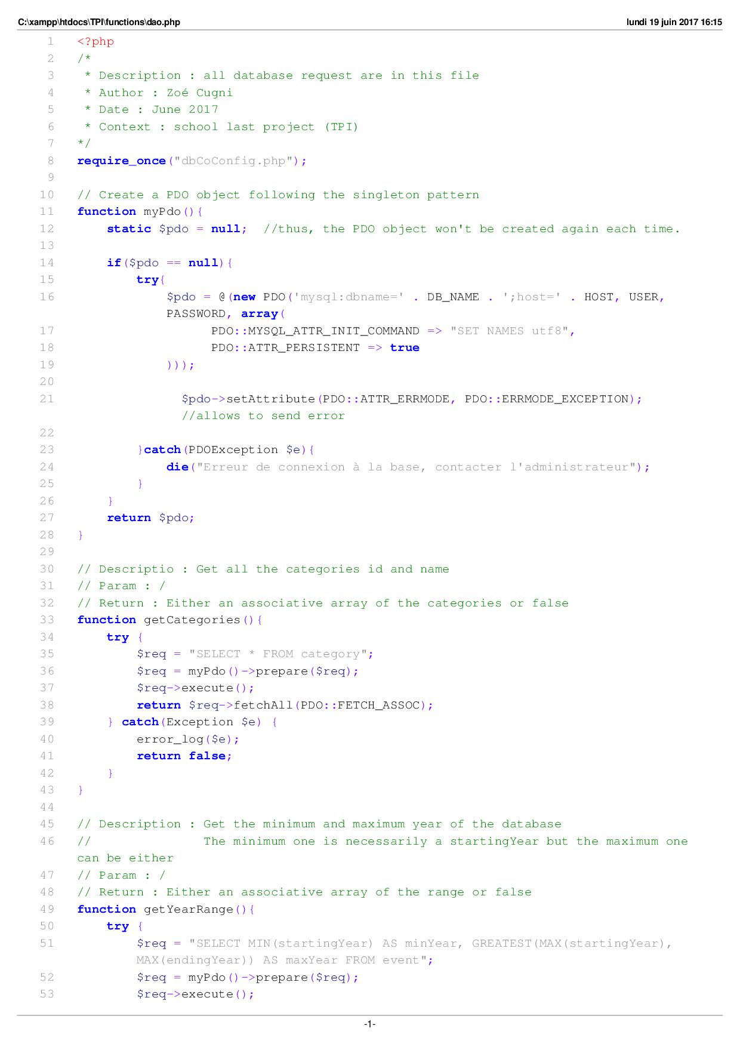

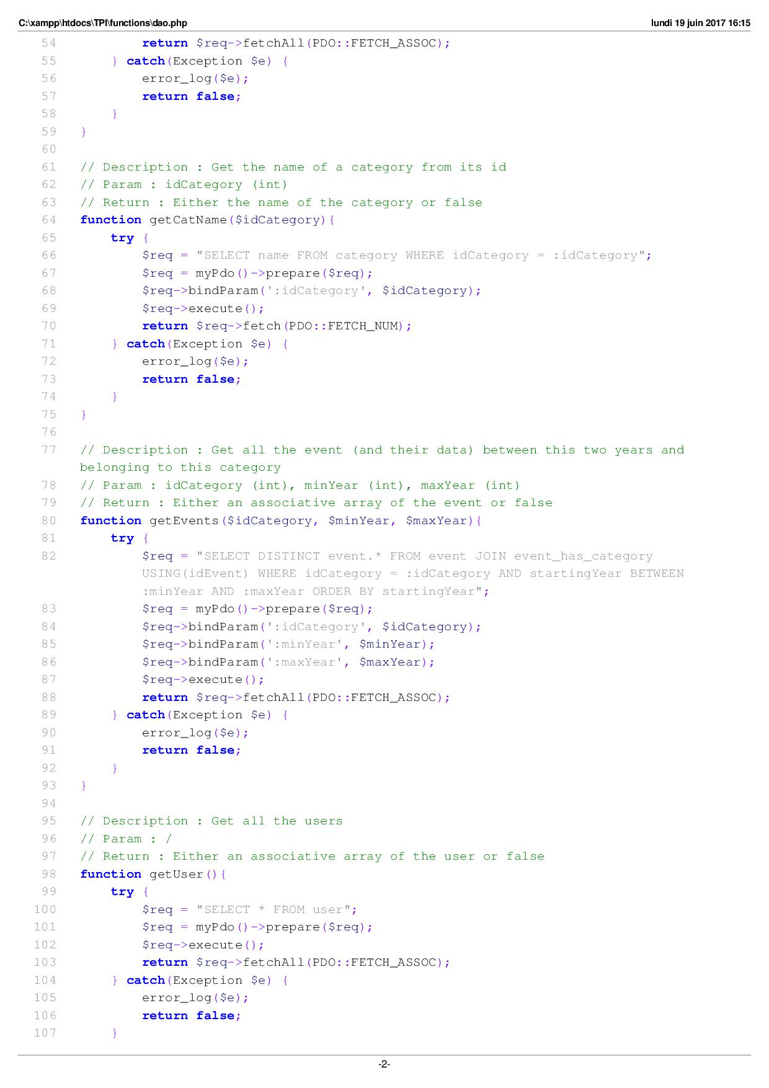

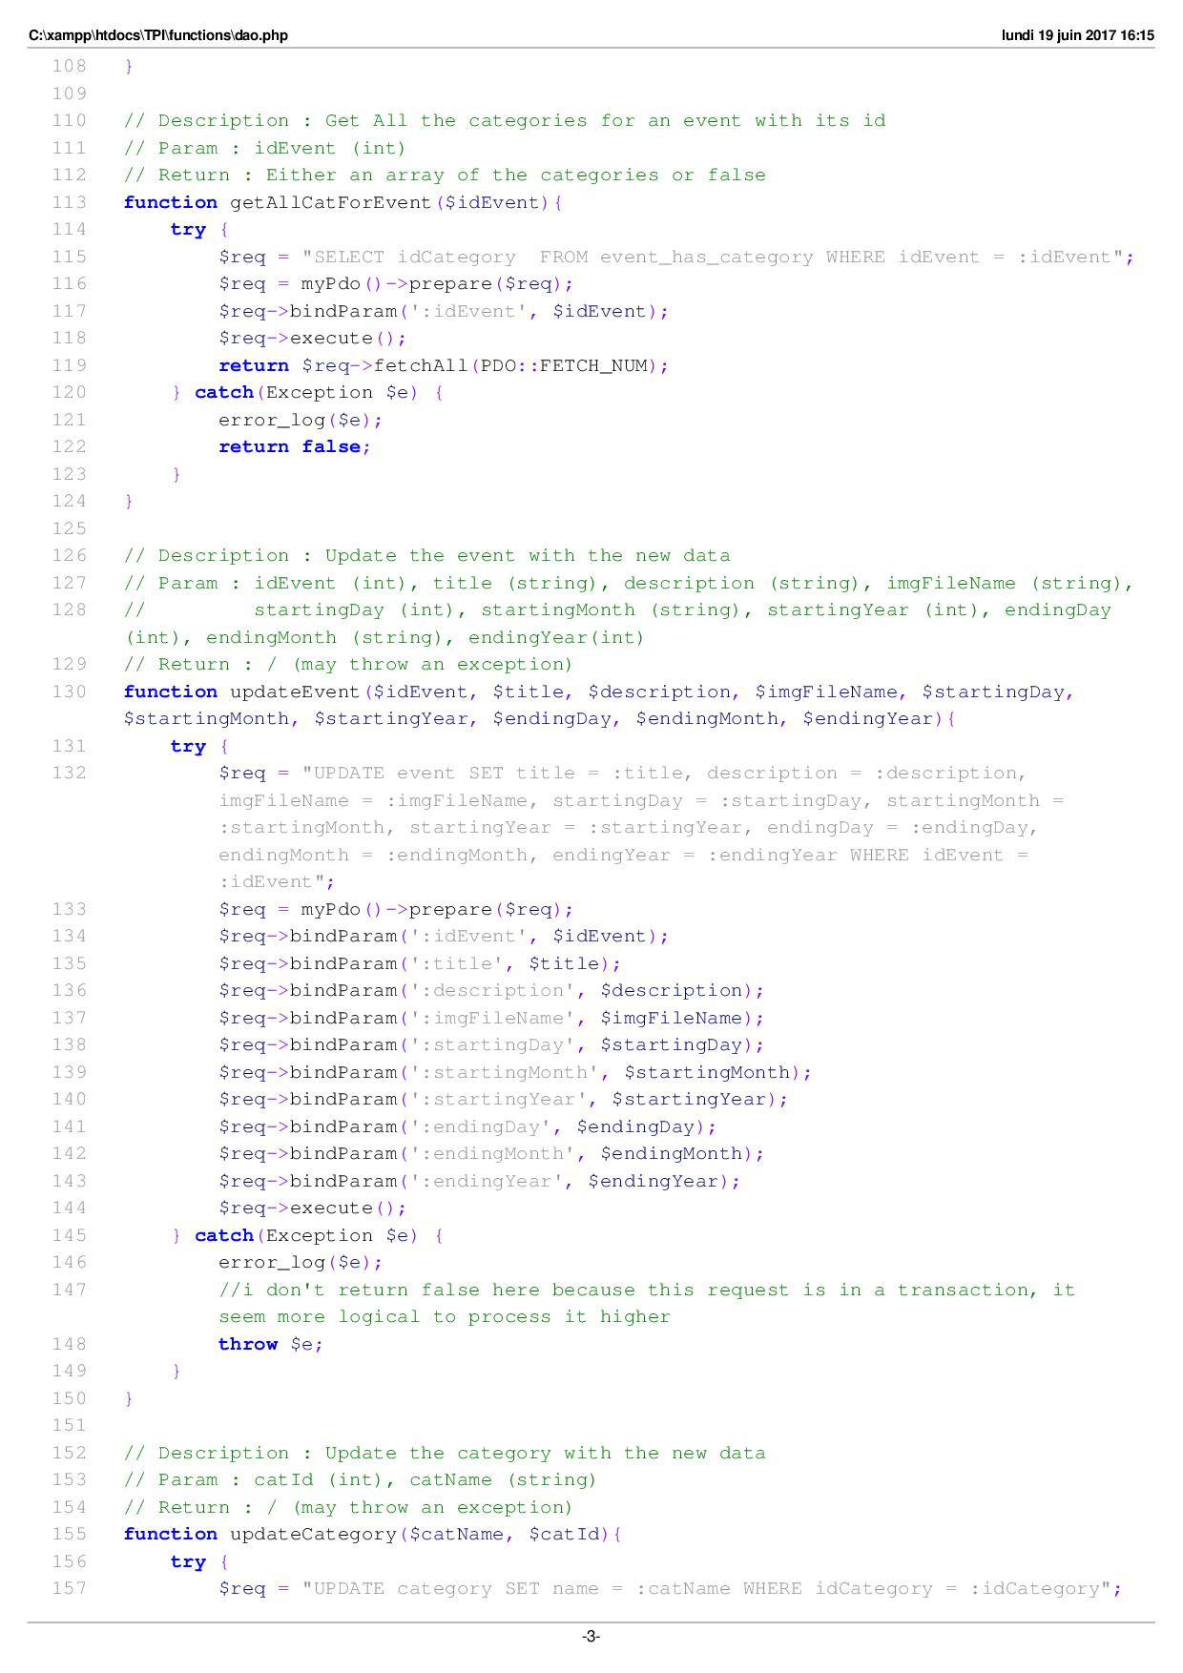

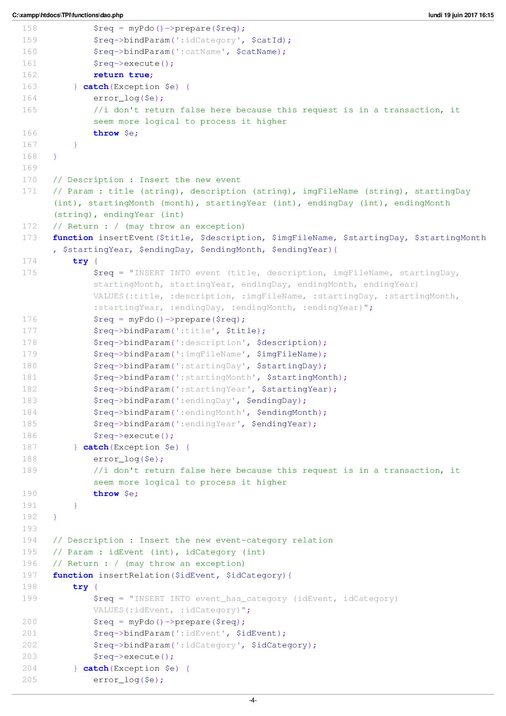

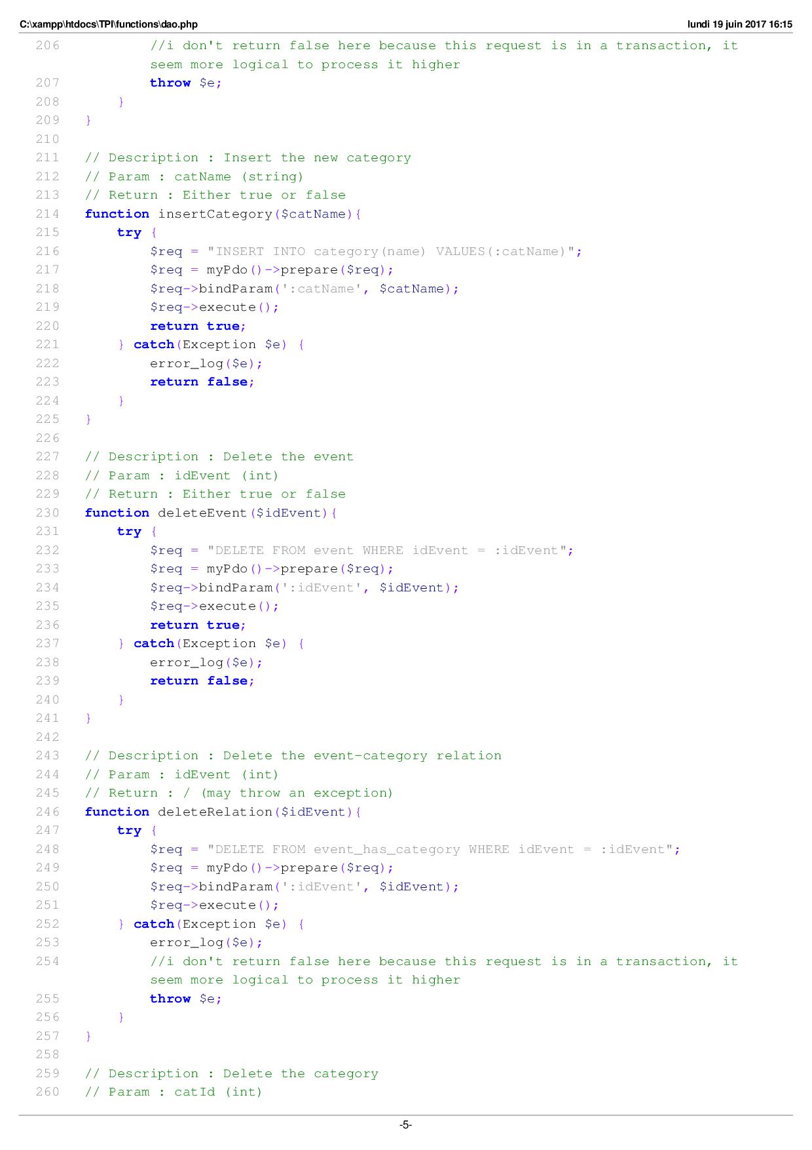

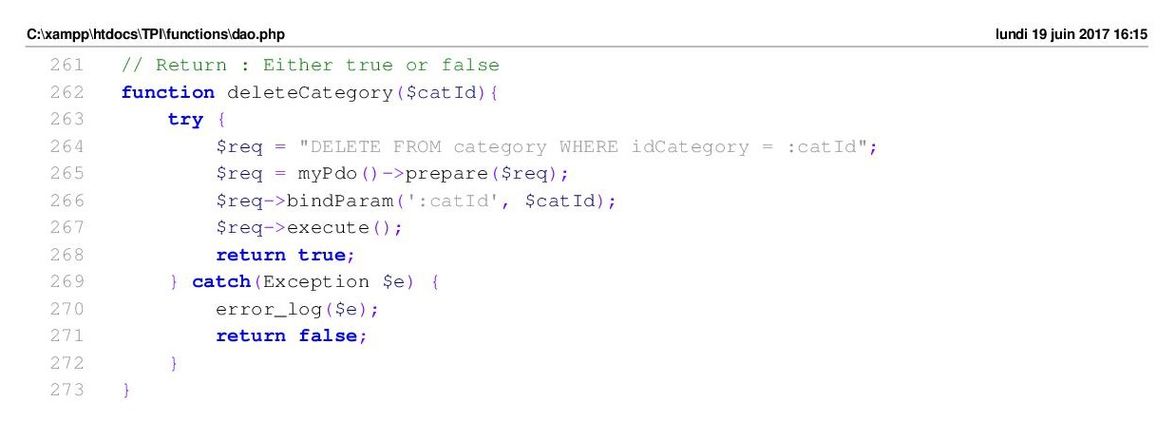

# Functions/dbCoConfig.php

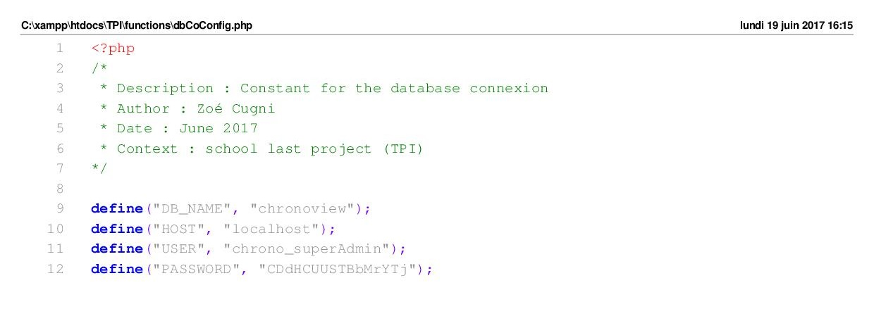

# Functions/interlocutor/event.php

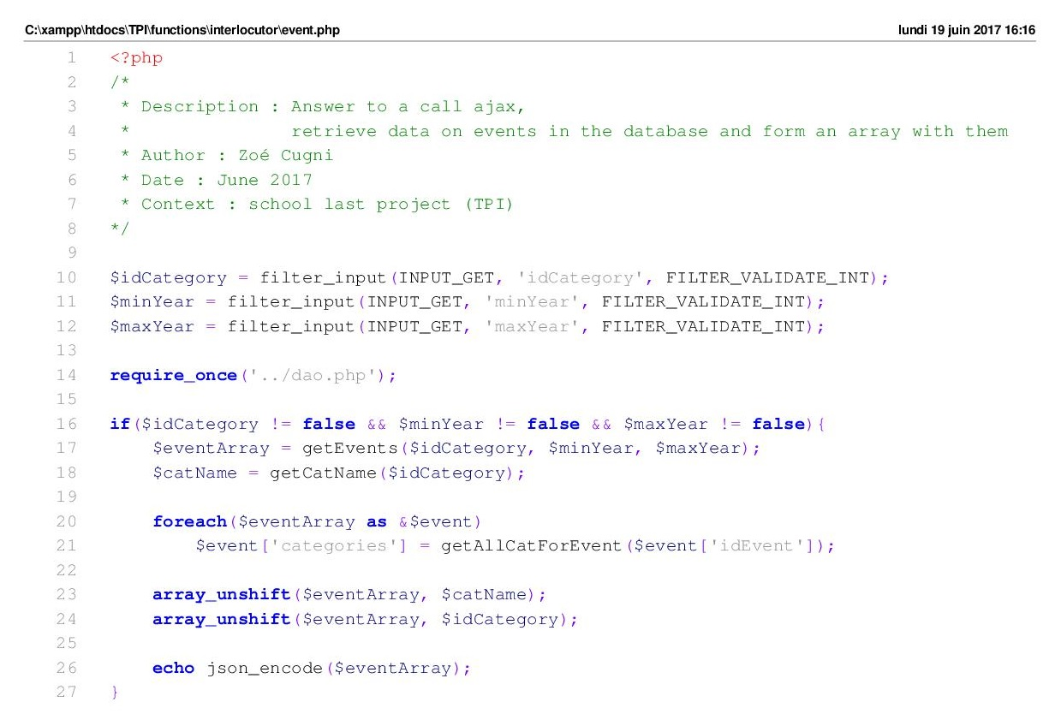

# Functions/interlocutor/getCategories.php

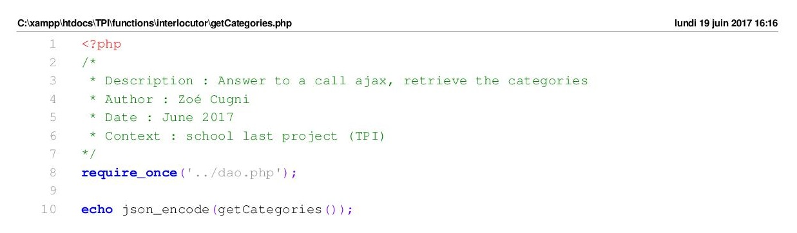

# Functions/interlocutor/getSession.php

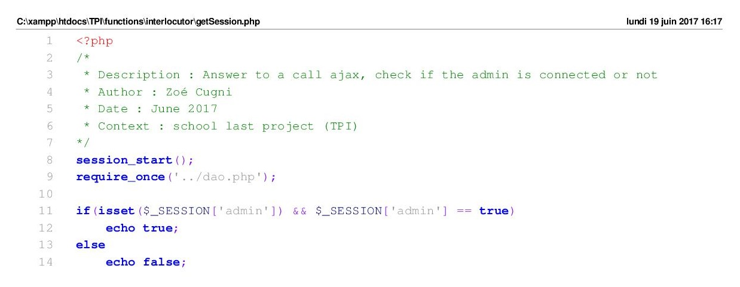

# Functions/interlocutor/loginCheck.php

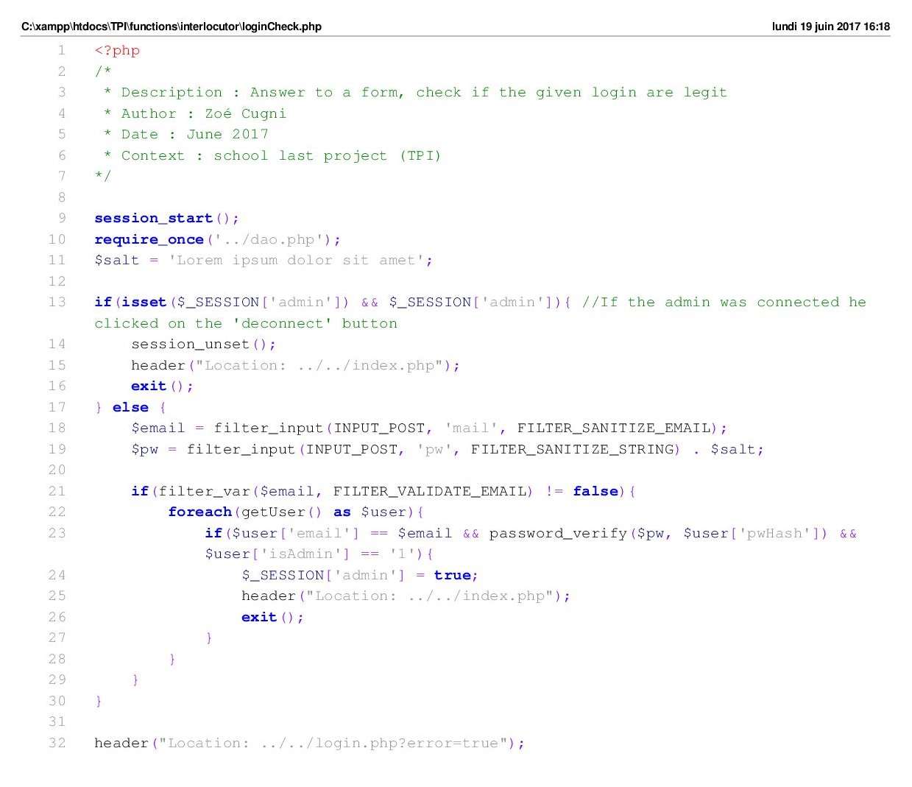

# Functions/interlocutor/rangeYear.php

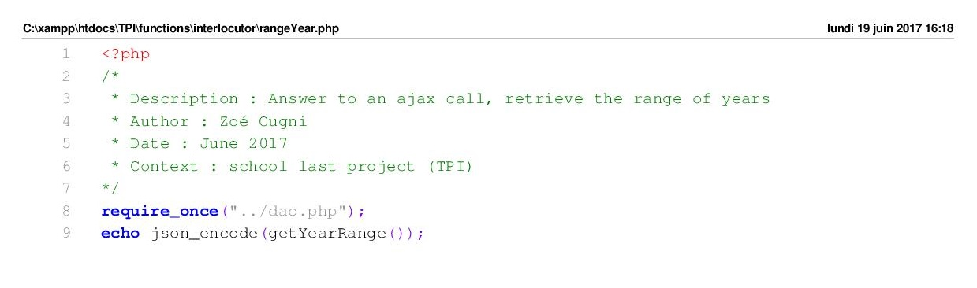

# Functions/interlocutor/updateEvent.php

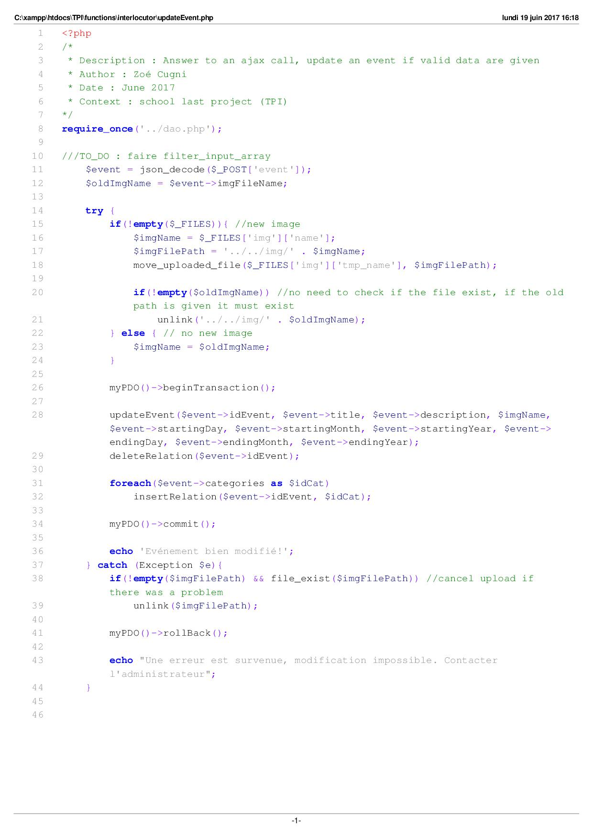

# Functions/interlocutor/updateCategory.php

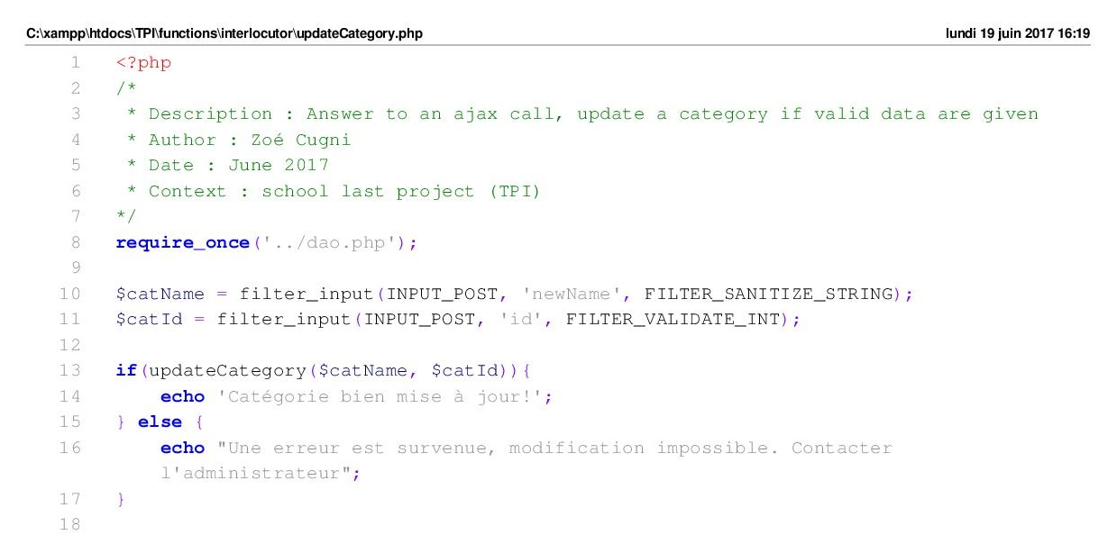

# Functions/interlocutor/insertCategory.php

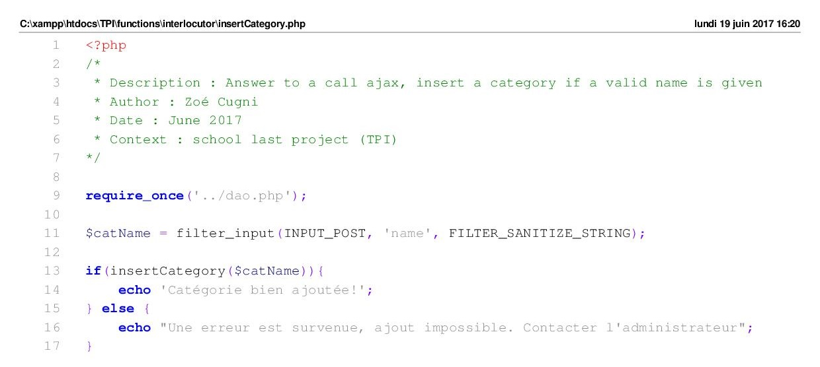

# Functions/interlocutor/insertEvent.php

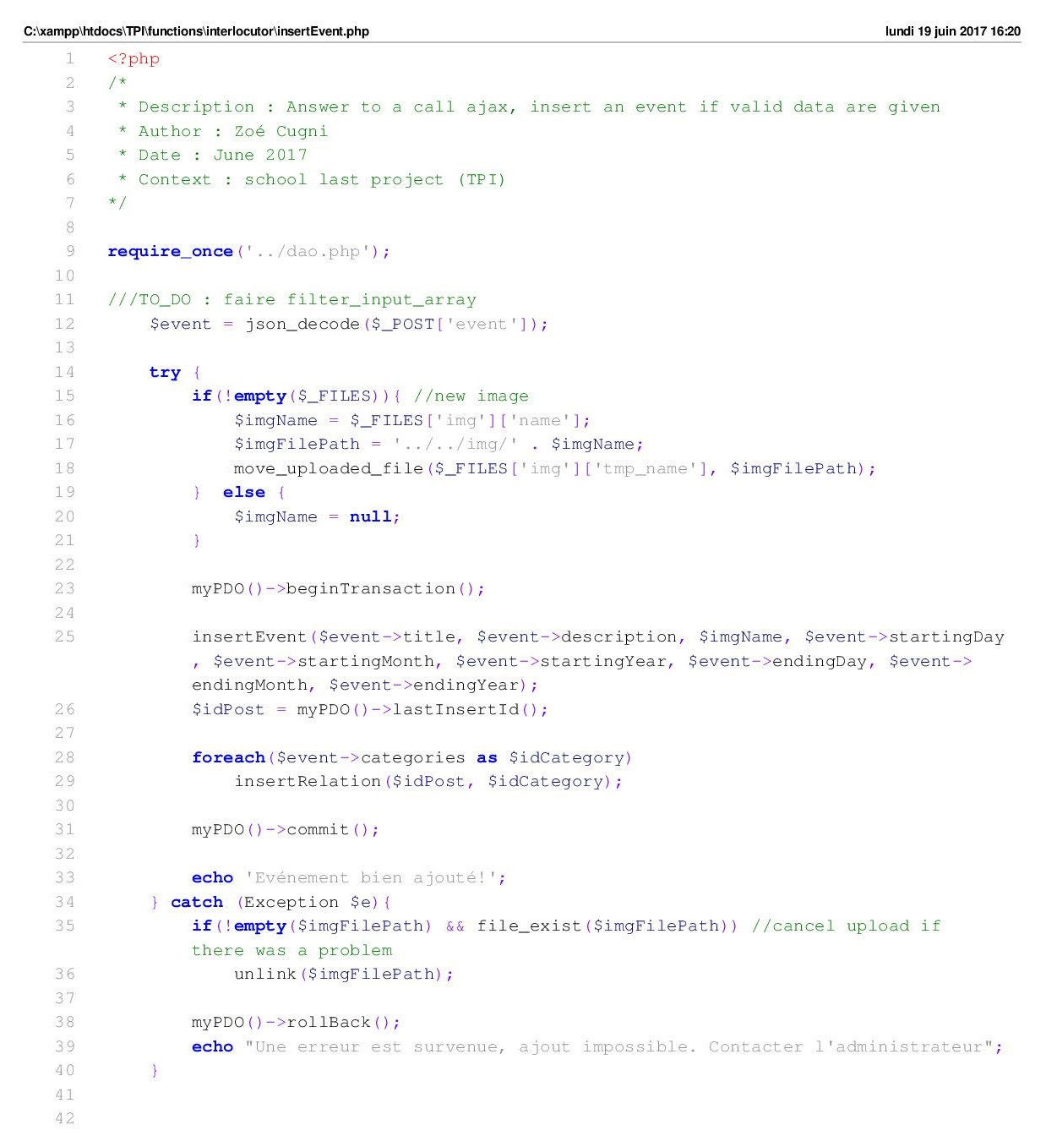

# Functions/interlocutor/deleteCategory.php

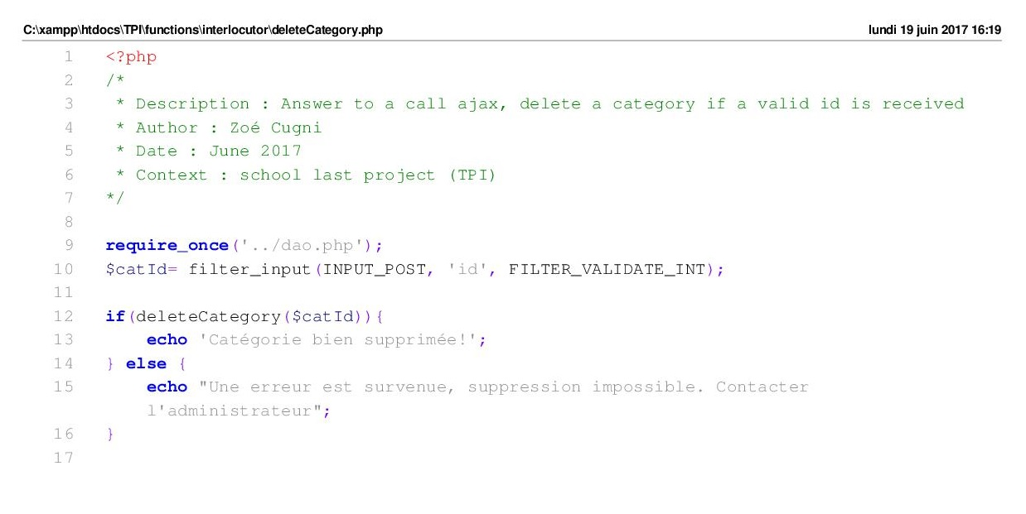

# Functions/interlocutor/deleteEvent.php

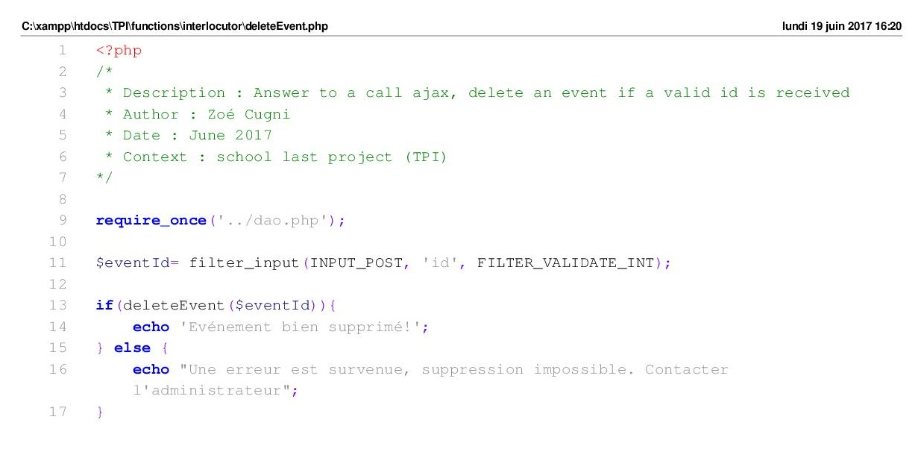

# Css/style.scss

